**Face shape recognition project Hairdressing.**

Hello Diego,

Some notes for you.

These are the most common face shapes students need to know about.

Medium-length hair is best, as long hair can pull the face down and super short hair can make the face shape look more severe.

A **chin-length bob** looks especially nice on a long face, as well as bangs, which can both make the face appear shorter

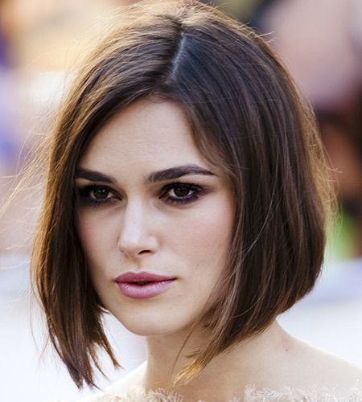

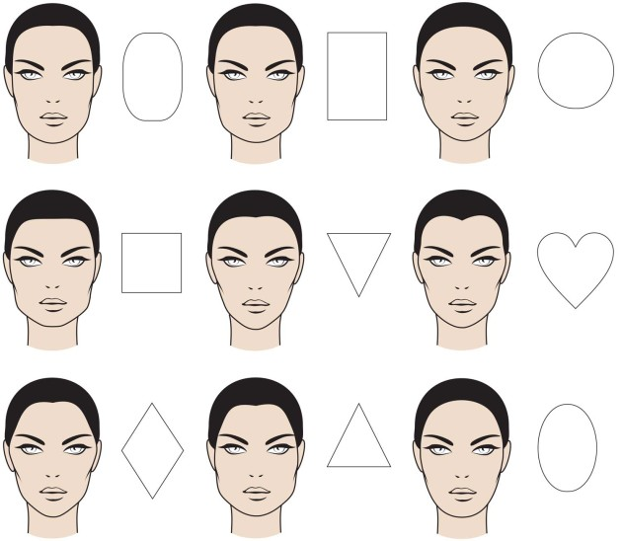

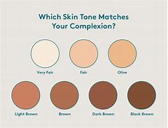 if the app can recognise skin tone, this is useful for beauty and hairdressing with colour selection.

A warm tone hair colour is your best choice if your **skin** looks good against **shades** of red, orange or yellow. Choose a hair colour based on your **skin tone**. Black, ash blondes, ash browns and platinum blondes generally look good on cool **skin tones**. Golden brown, golden blonde and warm reds typically look good on warm **skin** tones.

<https://www.youtube.com/watch?v=JW943imfddQ>

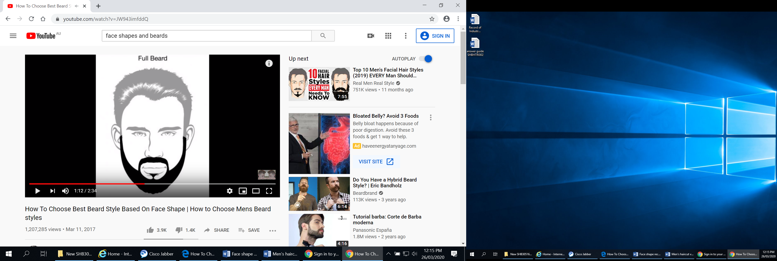

Hairdressing apps you may want to look at.

<https://myhairdressers.com/>

Wella. Education <https://apps.apple.com/us/app/wella-professionals-education/id937712338>

Goldwell <https://www.goldwell.com/en-au/education/>

<ww.shannelmariano.com/education>

Future planning interactive for our cutting units,

3D IMAGERY, ROTATING HEAD

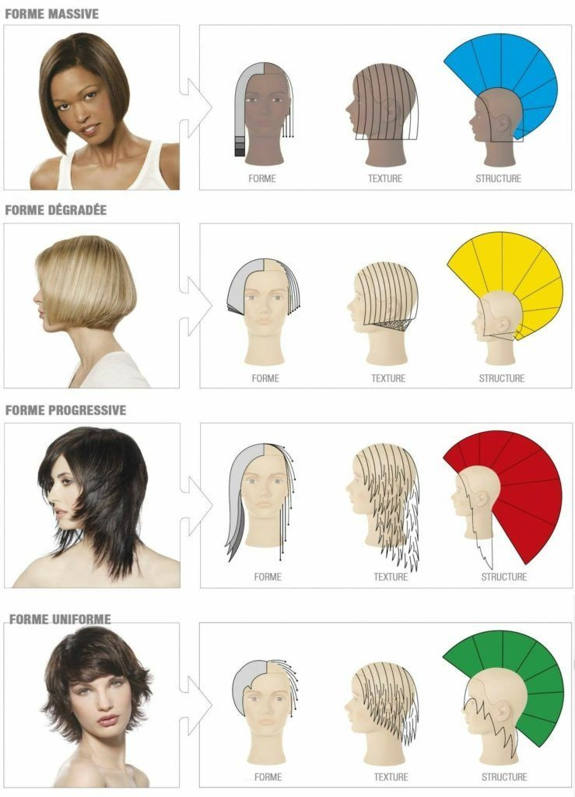

Colour pallet for mixing colours

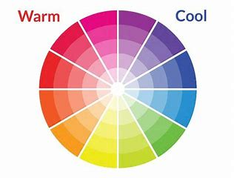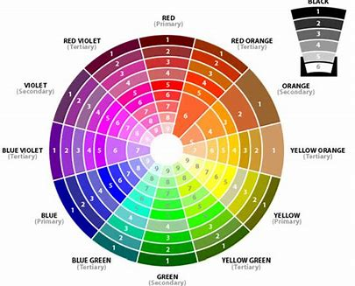

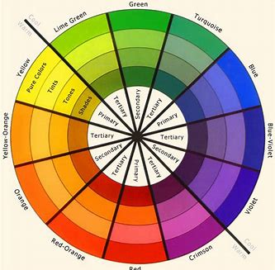 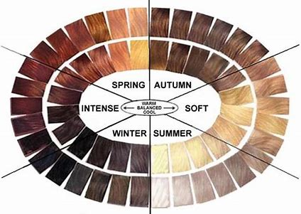 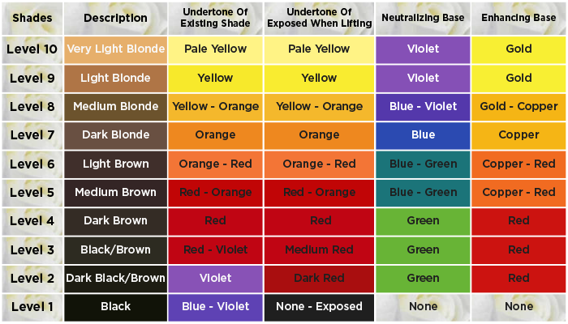

<https://www.sessions.edu/color-calculator/>